***Davis Data Science Club***

*Spring 2023*

*Sign Language Detection*

**Object Detection API Installation**

Reference for Installations: <https://tensorflow-object-detection-api-tutorial.readthedocs.io/en/latest/install.html>

I faced version problems again while model training for 26 alphabets, so here’s what I did.

1. Update Python and Conda
2. Create a new Anaconda virtual environment
3. Activate the Anaconda virtual environment
4. Install Tensorflow PIP Package
5. Verified the installation
6. **SKIPPED**: CUDA, CUDNN (Must do if working on NVIDIA, macOS & Windows can skip)
7. Directly move to the Object Detection API Installation section:
   1. Downloading Tensorflow Model Garden from Git
      1. Created a new Folder called Tensorflow, go to the command line, and clone the git repo.

Note: I find cloning easier in this case

* 1. Download the latest protoc for your os: <https://github.com/protocolbuffers/protobuf/releases>
     1. Extracted everything from the zip folder to a new folder, ‘Google Protobuf’ in Desktop.
     2. Added the bin folder in Google Protobuf to my environment variable: ‘C:\Users\jenis\Desktop\Google Protobuf\bin’ - the path should look similar to this, change it according to your directory and the path your stored it in.
     3. Open a new terminal and cd into ‘Tensorflow/models/research’ according to your path- this is the ‘Tensorflow’ folder we created in Step 7.a.i.
     4. Run this command in the terminal:

protoc object_detection/protos/*.proto --python_out=.

* 1. COCO API Installation for pycotools dependency
     1. Follow the steps mentioned in the screenshot below.

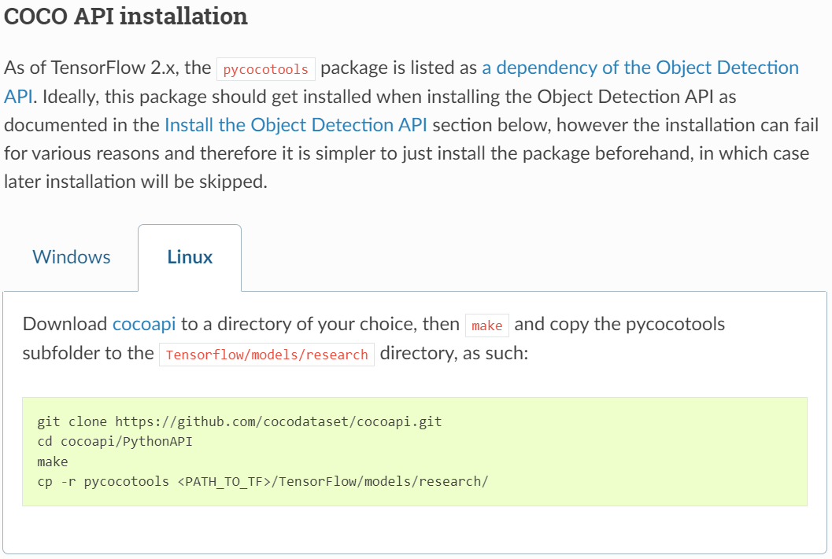

* 1. Install Object Detection API
     1. (In the terminal: cd Tensorflow/models/research) run the following commands:
        1. cp object_detection/packages/tf2/setup.py .
        2. python -m pip install .
     2. Test the installations using this command:
        1. python object_detection/builders/model_builder_tf2_test.py

**Training Model**

**Real-Time Detection**